**2024 Badge Final Assembly**

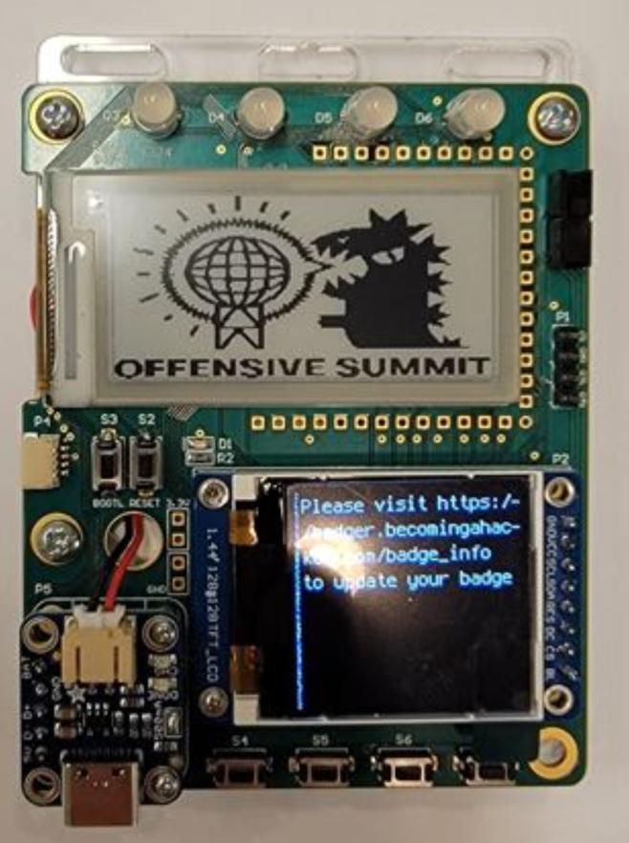

**1.44” TFT LCD Installation**

1. Solder 2.54mm header into bottom side of TFT LCD
2. Install standoffs into P2 on the top side of the PCB
3. Insert TFT LCD pins into P2 Receptacle
4. Attach TFT LCD to standoffs using screws

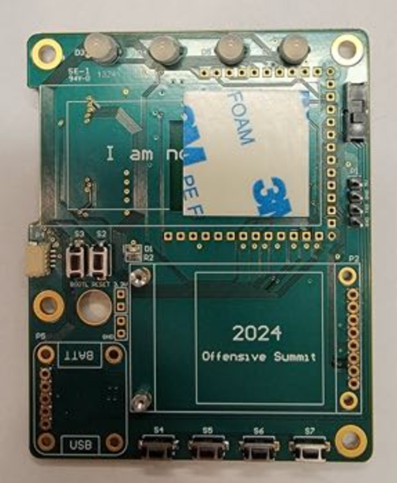 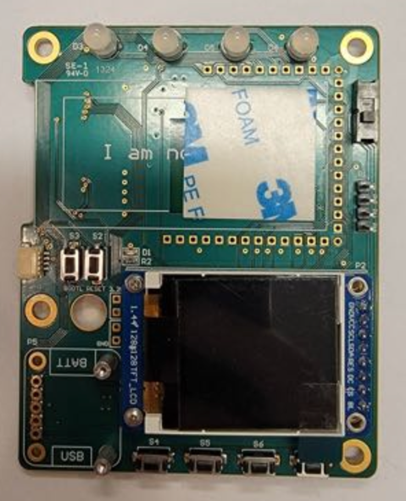

**Micro Lipo Module Installation**

1. Solder 2.54mm header into bottom side of Micro Lipo Module
2. Install standoffs into P5 on the top side of the PCB
3. Insert Micro Lipo module pins into P5 receptacle
4. Attach Micro Lipo module to standoffs using screws

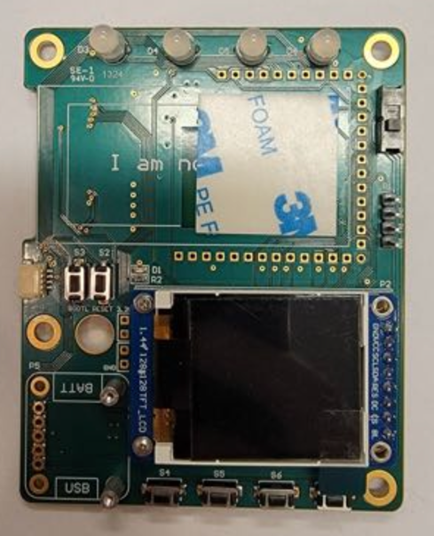 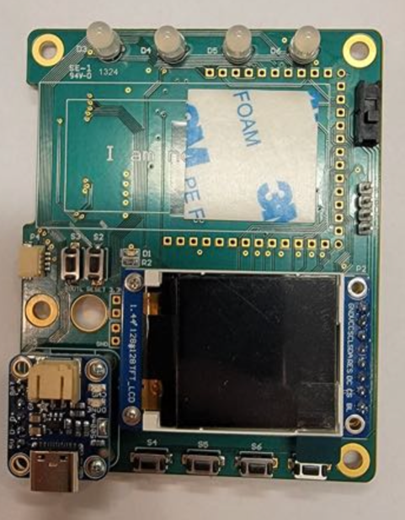

**Electronic Paper Display (EPD) Installation:**

1. Apply the double sided adhesive foam pad to P3 outline on the top side of the PCB
2. Install EPD into P3 connector on the bottom side of the PCB
3. Wrap EPD flat printed circuit cable around the PCB
4. Gently press EPD into the double sided adhesive foam pad on top side of the PCB

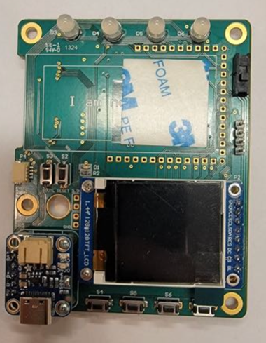 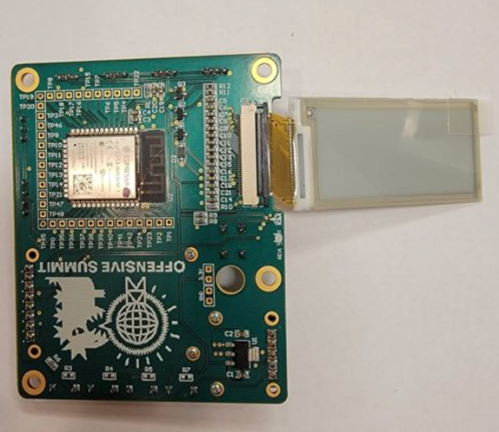 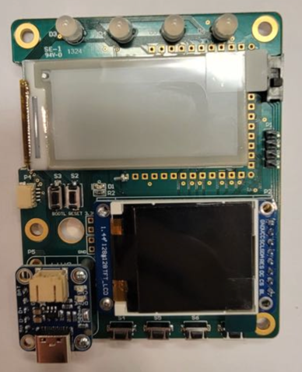

**Battery Installation:**

1. Set U1 switch to the 5V/Off position
2. Route the battery connector through the hole in the PCB above P5
3. Attach battery to micro lipo module
4. Turn on assembly to test by Setting U1 switch to the BATT position

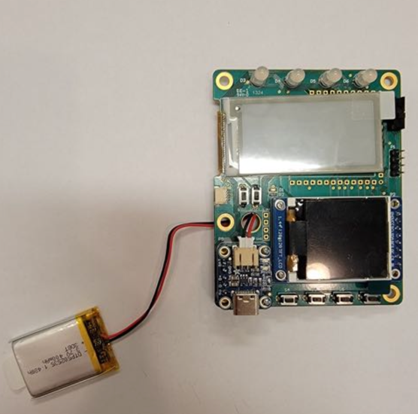 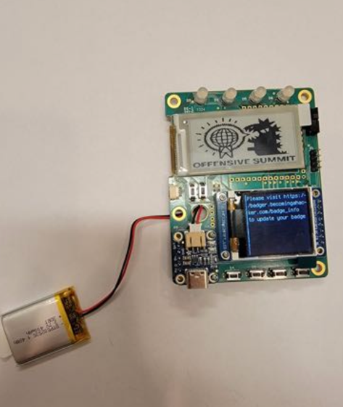

**Backing Plate Installation:**

1. Apply double sided adhesive foam pad to the battery
2. Remove protective film
3. Mount battery on PCB bottom side over the Offensive Summit graphic
4. Install Standoffs onto backing plate
5. Mount PCB assembly to the backing plate using screws

